Green’s Windmill & Science Centre

Volunteer Application Pack
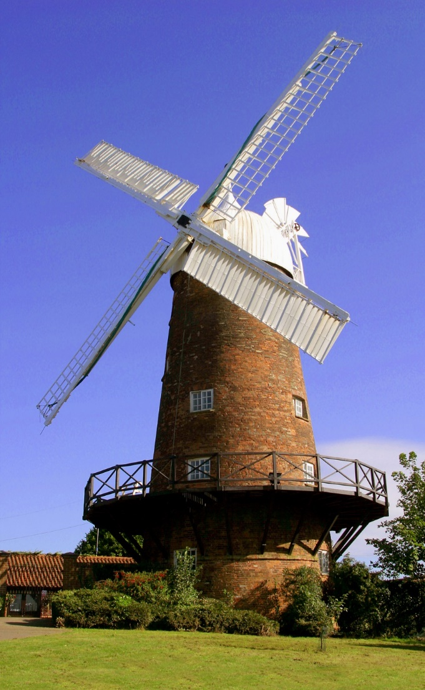

Green's Windmill is a restored and working 19th Century tower mill. Built in 1807 by the father of celebrated scientist and mathematician George Green, it is the only city-based working windmill in the UK. In 2013, the Green’s Windmill Trust (charity no.1163116) took over the running of the windmill from Nottingham City Council, and today is reliant on volunteers to help keep the windmill open and operational for the enjoyment of others.
Many types of flour are still produced at the mill and tours can be taken to see the mill in action. In the interactive Science Centre visitors can discover the remarkable story of George Green, and experiment with light, electricity and magnetism. A community garden adjacent to the windmill also opened in 2016 and is a great addition to the site. Baking and craft events take place all year round for both the public and private group bookings. School groups visit all year round too, whilst children’s birthday parties are a popular feature.
The Green’s Windmill Trust is now searching for volunteers to assist with operations at the windmill and more details of each role can be found over the next pages. If you would like to apply please complete this form and return it at your convenience.
Green's Windmill is about 1¼ miles east of Nottingham City Centre and is a 15 minute walk from the city centre and the railway station. A no.43 bus can be caught from outside Boots in the city centre which will drop you near Windmill Lane in Sneinton.

Role Title: | Visitor Services Assistant
Where: | Green’s Mill Science Centre, Windmill Lane, Sneinton, Nottingham, NG2 4QB
Commitment: | Ideally, at least one day per week.
When: | Wednesday to Sunday, 10am – 4pm
Attitude: | We expect our volunteers to provide excellent customer service to visitors so that they have a great experience and want to return.  Sneinton is a wonderfully multi-cultural area of the city and we expect volunteers to embrace this and encourage a wide range of people to feel welcome to the site.
Skills and experience: | No previous experience is needed for this role.  We are looking for people who can provide a friendly face to our visitors and we will make the most of your individual skills and experience.  Volunteers will be given a full induction to Green’s Windmill, and training and support to carry out the role.
Main duties: | - Welcome visitors to Green’s Windmill & Science Centre and answering basic questions about the site.  - Direct people to special events and temporary exhibitions.  - Answer the telephone and taking messages.  - Complete booking forms and receipts.  - Promote and sell merchandise to customers.  - Basic cleaning of museum areas to make things look presentable.  - Assist the team with events and activities.  - Help Green’s Windmill to ensure good health and safety for visitors, volunteers and staff.
What’s in it for you? | This is a fantastic personal and professional development opportunity! It will make you feel valued in a friendly community setting and allow you to gain experience of working at a unique museum site and specialise in an area you enjoy or want to develop.  Be a part of a museum that’s going through an exciting development phase and be involved in key decisions and changes to maximise the museums potential.  You will learn new and transferable skills to launch you into or back into employment if you wish and increase your confidence.  Your time with us will be rewarded in many ways. We will celebrate our achievements as a team with volunteer parties, project launches and occasional incentives such as day trips.
Supervision: | If required, volunteers can work in pairs until a volunteer is confident working alone.
Contact information: | Jamie Duff, Heritage Development Officer  Email: greens.mill@nottinghamcity.gov.uk or Tel: 0115 915 6878
Role Title: | Events & Activities Co-ordinator
Where: | Green’s Mill Science Centre, Windmill Lane, Sneinton, Nottingham, NG2 4QB
Commitment: | Ideally, at least one day per week.
When: | Wednesday to Sunday, 10am – 4pm
Attitude: | We expect our volunteers to provide excellent customer service to visitors so that they have a great experience and want to return.  Sneinton is a wonderfully multi-cultural area of the city and we expect volunteers to embrace this and encourage a wide range of people to feel welcome to the site.
Skills and experience: | No previous experience is needed for this role. Volunteers will be given a full induction to Green’s Windmill, and training and support to carry out the role.  We are looking for people with a love of local history, attention to detail, great communication skills (for speaking in public) and an outgoing manner with high standards for customer care.
Main duties: | - Develop memorable events and educational activities suitable to the themes of the site – science, heritage, environment, art and maths – that will be engaging, accessible and suitable for our visitors while encouraging new audiences.  - Deliver the events and activities with creativity and enthusiasm!  - Encourage people to attend events and activities through word of mouth and by marketing them well.  - Basic cleaning of museum areas to make things look presentable, especially after an event or activity.  - Helping Green’s Windmill to ensure good health and safety for visitors, volunteers and staff.
What’s in it for you? | This is a fantastic personal and professional development opportunity! It will make you feel valued in a friendly community setting and allow you to gain experience of working at a unique museum site and specialise in an area you enjoy or want to develop.  Be a part of a museum that’s going through an exciting development phase and be involved in key decisions and changes to maximise the museums potential.  You will learn new and transferable skills to launch you into or back into employment if you wish and increase your confidence.  Your time with us will be rewarded in many ways. We will celebrate our achievements as a team with volunteer parties, project launches and occasional incentives such as day trips.
Supervision: | If required, volunteers can work in pairs until a volunteer is confident working alone.
Contact information: | Jamie Duff, Heritage Development Officer  Email: greens.mill@nottinghamcity.gov.uk or Tel: 0115 915 6878

Role Title: | Gardener
Where: | Green’s Mill Science Centre, Windmill Lane, Sneinton, Nottingham, NG2 4QB
Commitment: | Ideally, at least one day per week.
When: | Currently only on Fridays, 10am – 4pm
Role Summary: | Green’s Windmill is a restored 19th Century tower mill in Sneinton, and home of famous mathematical physicist George Green. The Green’s Windmill Trust has taken on an allotment next door to the mill, renovating the plot. This has extended the outdoor space, and offers beautiful grounds for the public to enjoy. The large plot needs continuing work to help it flourish.  We are looking for people with an interest in gardening to join our group of friendly and enthusiastic volunteers to develop and tend this plot.
Main activities/tasks: | Help care for our allotment. Tasks include;  • All aspects of garden maintenance; weeding, cutting back overgrowth, sweeping etc.  • Sowing, planting and harvesting  • Propagation  • Maintenance and upkeep of garden structures  • Watering and feeding  • Development of the allotment project  • Attend meetings as necessary
Skills and Experience: | A pleasant and helpful manner and willingness to learn.  Good communication skills. Enthusiasm for history and heritage. Ability to work in a team with volunteers and site staff.  No gardening experience needed.
What’s in it for you? | This is a fantastic personal and professional development opportunity! It will make you feel valued in a friendly community setting and allow you to gain experience of working at a unique museum site and specialise in an area you enjoy or want to develop.  Be a part of a museum that’s going through an exciting development phase and be involved in key decisions and changes to maximise the museums potential.  You will learn new and transferable skills to launch you into or back into employment if you wish and increase your confidence.  Your time with us will be rewarded in many ways. We will celebrate our achievements as a team with volunteer parties, project launches and occasional incentives such as day trips.
Contact information: | Jamie Duff, Heritage Development Officer  Email: greens.mill@nottinghamcity.gov.uk or Tel: 0115 915 6878

Volunteer Application Form

Thank you very much for your enquiry concerning volunteering with Green’s Windmill & Science Centre. Please complete this application form indicating which role(s) you are applying for and when you are available to volunteer.
If you require this information in another format please contact Jamie Duff on 0115 9156878.

Personal details
Name: ………………………………………………………………..
Address: ………………………………………………………………..
………………………………………………………………..
Tel: ……………………………………………............................
email: …………………………………………………………………

Availability
Please indicate the approximate days of the week and times that you would be available to volunteer by ticking the chart below. This can be finalised at volunteer induction, or on a weekly basis depending on your availability:
Preferred day or days | Full day (9.30am – 4pm) | Morning (9.30am – 1pm) | Afternoon(1pm – 4pm)
Wednesday
Thursday
Friday
Saturday
Sunday

Available from (start date): …………. Available until (end date, if applicable): ………...

Volunteer roles
Please consider the various volunteer roles and read the volunteer role descriptions carefully before indicating below which role(s) you are applying for:

Visitor Services Assistant
Events & Activities Co-ordinator
Gardening Volunteer
Other – please suggest
Information to support your application

Please use this space to describe why you are interested in volunteering at Green’s Windmill & Science Centre. Also please list any skills / experience that you feel would be beneficial to a voluntary placement or that you feel you would like to develop:

……………………………………………………………………………………………………………

……………………………………………………………………………………………………………

……………………………………………………………………………………………………………

……………………………………………………………………………………………………………

……………………………………………………………………………………………………………

……………………………………………………………………………………………………………

……………………………………………………………………………………………………………

……………………………………………………………………………………………………………

References

Please can you provide contact details of two professional referees;

1.………………………………………………………………………………………………………
….………………………………………………………………………………………………………
2..………………………………………………………………………………………………………
…………………………………………………………………………………………………………
- Current Referees? Yes No

- CV attached Yes No

Sign…………………………………… Date……………………..

To confirm your interest
Please return this application form via email to greens.mill@nottinghamcity.gov.uk or post to:
Jamie Duff
Green’s Windmill & Science Centre
Windmill Lane
Nottingham
NG2 4BQ

Thank you very much for your time. We will be in contact with you very soon regarding your application. Please indicate how you found out about our volunteering opportunities:

……………………………………
Details will be kept on file in accordance with The Data Protection Act 1998.
Equal Opportunities Monitoring Form

Green’s Windmill & Science Centre aims to provide equal opportunities and fair treatment for all volunteers. Please complete this form in order to help us understand who we are reaching and to better serve everyone in our community. The information will be used to provide an overall profile analysis of our volunteer base.
All details are held in accordance with the Data Protection Act 1998.
You do not have to answer any questions you are uncomfortable with.

- Which gender do you identity with:

- Which age group do you fall into:
16 – 19 20 – 24 25 – 34 35 – 44
45 – 54 55 – 64 65 – 74 75 or over

- How would you describe your ethnic origin:
White British Mixed heritage
White other Asian or Asian British
White European Chinese
Black or Black British
Other ethnic group Please state

- Would you describe yourself as having a disability or impairment?
Yes No

- Which category do you fall into:
Student Employed Self-employed
Unemployed Retired
Other Please state

Thank you for completing this form.

Volunteer Emergency Contact Details

Volunteer Name:

Emergency contact information:
Do you have any health conditions that we should be aware of, such as epilepsy? Please specify below.

Emergency contact name (1)………………………………………………………………

Contact number/s………………………………………………………….........................

Emergency contact name (2)………………………………………………......................

Contact number/s…………………………………………………………………………….

